COMPUTER SCIENCE FUNDAMETAL AND CAREER PATHWAYS

Assignment Number 02: Basics of Linux and Open-Source Tools
Assignment Title: How Can You Demonstrate Linux Setup, Command Usage, and Automation Through Practical Implementation?

Submitted By:
Name: Jiya Sinha
Roll No.: 2501010150
Course Code: ETCCCP105
Programme: B.Tech CSE Core
Section: B
Semester: 1

Submitted To:
Rajesh Kumar Sir

INTRODUCTION:
The purpose of this assignment is to learn how to install and use a Linux operating system — specifically Ubuntu — in a virtual environment using VirtualBox. It helps us to understand how to allocate system resources, install an OS safely without affecting the host machine, and perform basic shell operations.

IMPORTANCE OF LINUX :
Linux is based on the UNIX operating system. UNIX is a powerful, multi-user, multitasking operating system originally developed in the 1970s at AT&T Bell Labs. It laid the foundation for many modern operating systems, including Linux.
- Linux is free and open-source, accessible to everyone.
- Its source code can be inspected and modified by anyone.
- This promotes global collaboration and innovation.
- Linux offers efficient performance and strong security.
- It works well across many devices and industries.

IMPORTANCE OF SHELL SCRIPTING:
Shell scripts automate tasks in Linux by running a sequence of commands through the shell. They are essential because they:
- Automate repetitive tasks, saving time and reducing errors.
- Improve efficiency by quickly performing complex operations like backups or software setup.
- Ensure portability, as they can run on any UNIX-like system with minimal changes.
- Support debugging, making it easier to find and fix issues.
- Are easy to learn, sharing the same syntax as the Linux command line.

LINUX INSTALLATION:
Below are the documented steps for installing Linux:
- Step 1: Download Ubuntu ISO from the official website.
- Step 2: Install and open VirtualBox or enable WSL on Windows.
- Step 3: Create a new virtual machine and allocate CPU, RAM, and storage.
- Step 4: Select the Ubuntu ISO file and begin installation.
- Step 5: Complete setup with username, timezone, and updates.
- Hardware Used: 4 GB RAM, 2 Cores CPU, 30 GB Disk Space.

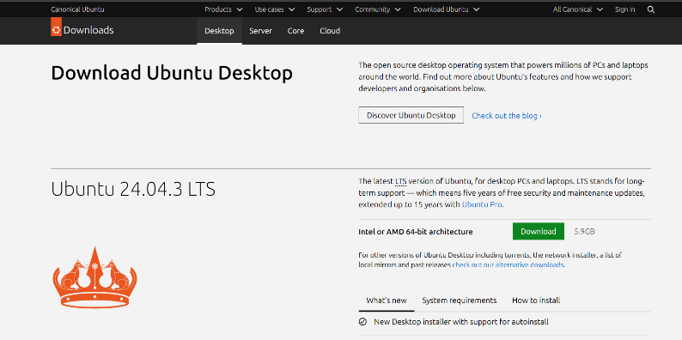

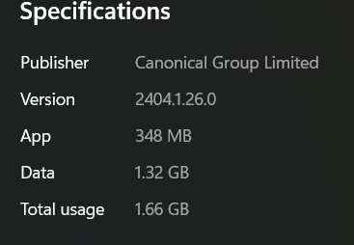

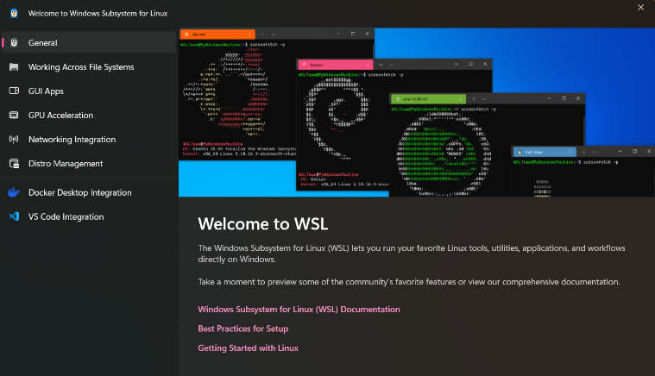
SHELL COMMAND DOCUMENTATION:
A total of 20 Linux commands are documented below:
- File Navigation
- Ls
Description: Lists files and directories in the current or specified directory.
Syntax: ls[options][directory]
Explanation: Used to see files and directories. Options like -l( long lasting ) and -a (all files including hidden ) are useful
Sample Output:
- cd
Description: Changes the current working directory.
Syntax: cd [directory]
Explanation: Navigate through directories to access files
Sample output :
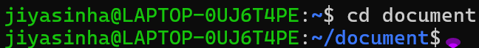
- pwd
Description: Displays the present working directory.
Syntax: pwd
Explanation: Confirms your current directory path, useful for scripting or navigation.
Sample output:
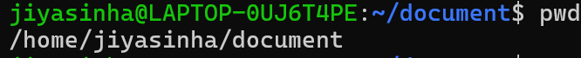
- tree
Description: Displays the directory structure in a tree format.
Syntax: tree [directory]
Explanation: Helps visualize folder hierarchy.

Sample output:
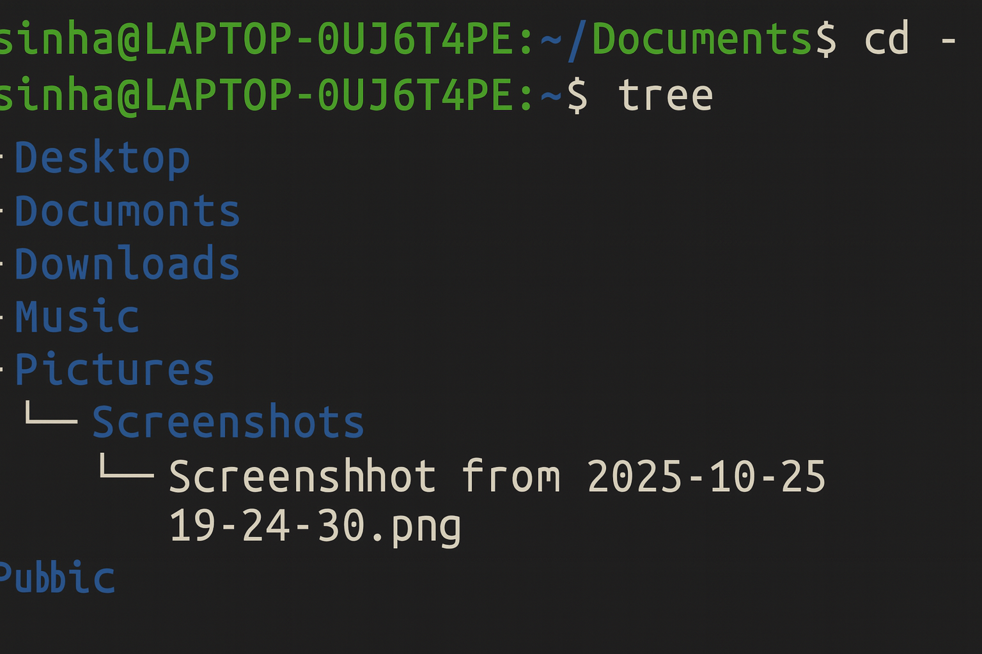
- FILE AND DIRECTORY MANAGEMENT
- Mkdir
Syntax: mkdir [directory_name]
Description: Creates a new directory.
Explanation: Useful to organize files into folders.
Sample output:
- Touch
Syntax: touch [filename]
Description: Creates an empty file or updates the timestamp.
Explanation: Quick way to create files.
Sample output:
- cp
Syntax: cp [source] [destination]
Description: Copies files or directories. Use -r for directories.
Explanation: Used to duplicate files or backup data.
Sample output:
- mv
Syntax: mv [source] [destination]
Description: Moves or renames files/directories.
Explanation: Organizes files or changes names.
Sample output:
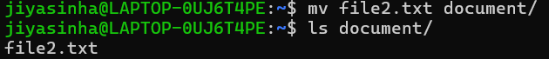
- rm
Syntax: rm [file]
rm -r [directory]
Description: Deletes files or directories.
Explanation: Removes unwanted files/directories. Use with caution.
Sample output:
- PERMISSIONS MANAGEMENT
  - chmod
Syntax: chmod [permissions] [file]
Description: Changes file or directory permissions.
Explanation: Controls who can read/write/execute files.
Sample output:
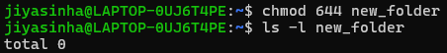

  - chown
Syntax: sudo chown [user]:[group] [file]
Description: Changes file or directory permissions.
Explanation: Controls who can read/write/execute files.
- PROCESS MONITORING
- Ps
Syntax: ps [options]
Description: Shows running processes. Use ps aux for all processes.
Explanation: Helps monitor system activity.
Sample output:
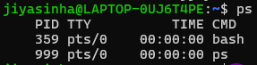
- Top
Syntax: top
Description: Real-time process monitoring with CPU and memory usage.
Explanation: Ideal for tracking system performance live.
Sample Output:
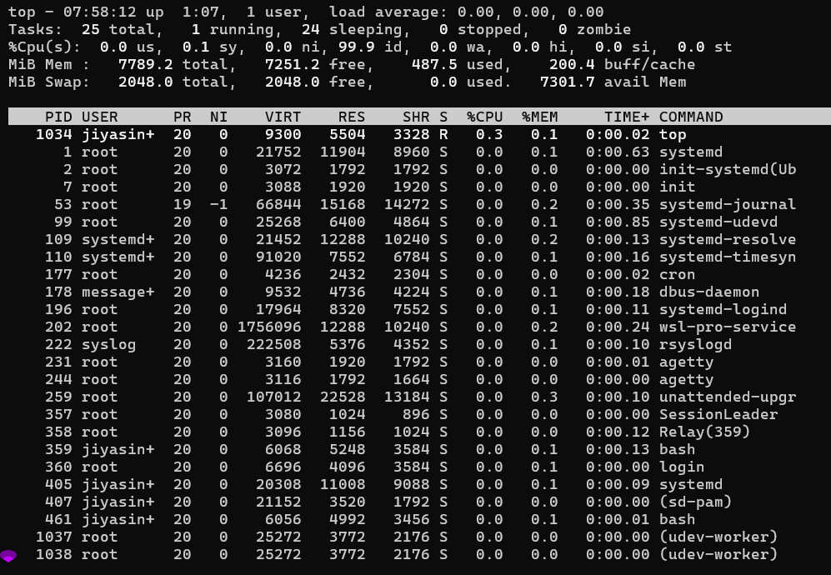

- Kill
Syntax: kill [PID]
Description: Terminates a process by its PID.
Explanation: Stops unresponsive or unnecessary processes.
Sample Output:
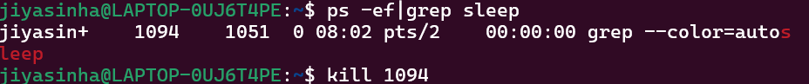
- NETWORKING TOOLS
- Ping
Syntax: ping [hostname/IP]
Description: Checks connectivity to another machine.
Explanation: Diagnoses network issues.
Sample output:
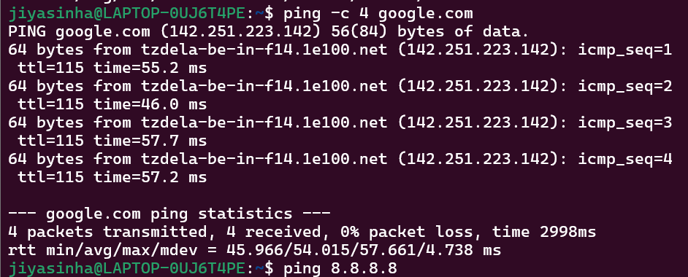
- Ifconfig / ip
Syntax: ifconfig
Ip addr show
Description: Displays network interface configuration.
Explanation: Checks IP, subnet, and network interfaces.
Sample Output:
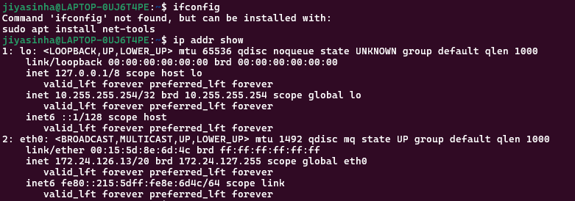
- Netstat
Syntax: netstat -tuln
Description: Shows active network connections and listening ports.
Explanation – Useful for network troubleshooting and monitoring open ports.
Sample Output:
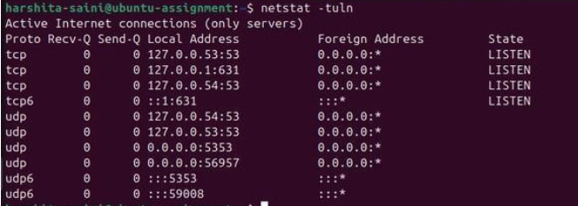

SHELL SCRIPT DEVELOPMENT
- Backup a Directory
#!/bin/bash
# ---------------------------------------------------------
# Script Name : backup.sh
# Author : Jiya Sinha
# Date : 15-11-2025
# Purpose : Backup a directory with a timestamp
# ---------------------------------------------------------

# Source directory to backup
SOURCE_DIR="/home/jiyasinha/Documents"

# Backup destination directory
BACKUP_DIR="/home/jiyasinha/backups"

# Create backup folder if not exists
mkdir -p "$BACKUP_DIR"

# Generate timestamp (YYYY-MM-DD_HH-MM-SS)
TIMESTAMP=$(date +"%Y-%m-%d_%H-%M-%S")

# Create backup file/folder name
BACKUP_NAME="backup_${TIMESTAMP}"

# Perform backup (copy folder with timestamp)
cp -r "$SOURCE_DIR" "$BACKUP_DIR/$BACKUP_NAME"

echo "Backup completed successfully!"
echo "Source : $SOURCE_DIR"
echo "Destination : $BACKUP_DIR/$BACKUP_NAME"
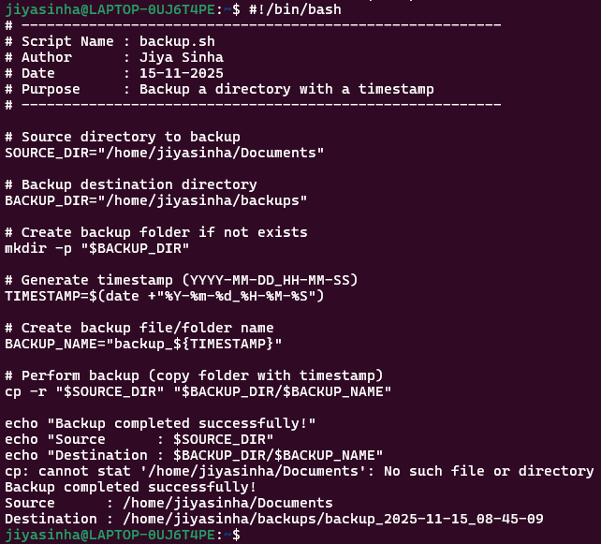

- CPU/ memory monitoring
#!/bin/bash
# --------------------------------------------------------------
# Script Name : system_monitor.sh
# Author : Jiya Sinha
# Date : 15-11-2025
# Purpose : Monitor CPU and Memory usage and log output
# --------------------------------------------------------------

# Log file location
LOG_FILE="/home/jiyasinha/system_usage.log"

# Print header
echo "--------------------------------------------------------" >> "$LOG_FILE"
echo "System Resource Usage Log - $(date)" >> "$LOG_FILE"
echo "--------------------------------------------------------" >> "$LOG_FILE"

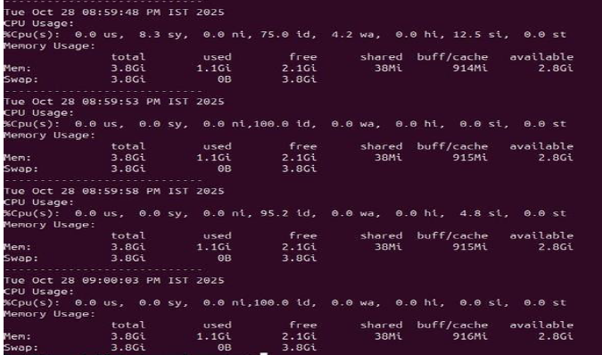
- Automated download task
#!/bin/bash
# -------------------------------------------------------------
# Script Name : download_file.sh
# Author : Jiya Sinha
# Date : 15-11-2025
# Purpose : Automatically download a file using wget/curl
# -------------------------------------------------------------

# URL of the file to download
FILE_URL="https://example.com/sample.pdf"

# Destination directory
DEST_DIR="/home/jiyasinha/downloads"

# Create destination directory if it doesn't exist
mkdir -p "$DEST_DIR"

# Extract file name from URL
FILE_NAME=$(basename "$FILE_URL")

echo "Starting download..."
echo "Downloading from: $FILE_URL"

# Download using wget
wget -P "$DEST_DIR" "$FILE_URL"

# Alternative using curl (uncomment if needed)
# curl -o "$DEST_DIR/$FILE_NAME" "$FILE_URL"

echo "Download completed!"
echo "Saved to: $DEST_DIR/$FILE_NAME"
- 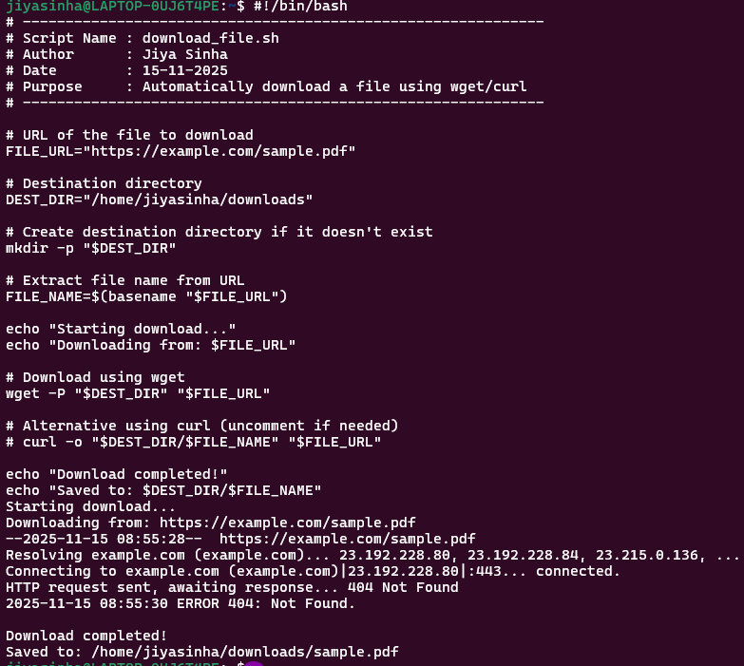
Reflection: Challenges Faced, Learning Outcomes, and Real-World Applications in Linux
- Challenges Faced:
While working with Linux, several challenges were encountered:
Understanding the command-line interface (CLI):
At first, remembering commands and their options such as mkdir, ls, chmod, and grep was difficult.
File permissions and ownership:
Managing permissions using chmod, chown, and symbolic/number modes was confusing initially.
Navigation and directory structure:
Learning to move across directories using cd, pwd, and using path concepts (absolute vs relative) required practice.
Shell scripting errors:
Small mistakes like missing #!/bin/bash, incorrect indentation, or syntax errors caused scripts to fail.
Package installation and dependency issues:
Sometimes commands like apt install raised dependency problems, which needed troubleshooting.
Working with WSL/VirtualBox:
Setting up environments, user issues, and missing GUI support caused delays.
- Learning Outcomes:
Through this experience, several valuable skills were gained:
- Mastery of essential Linux commands for file creation, navigation, editing, and system management.
- Understanding of the Linux file system including /home, /etc, /var, /bin, and root directory.
- Confidence in writing shell scripts for automation such as backup, monitoring, and scheduled tasks.
- Ability to manage users, permissions, and processes, making the environment more secure.
- Exposure to networking commands such as ping, ifconfig, netstat, and ssh.
- Hands-on experience with system updates and package management using apt, dpkg, and repositories.
- Application in real world scenarios
The skills learned in Linux are highly valuable in actual work environments:
- System administration:
Managing servers, configuring software, monitoring CPU/memory, and automating tasks.
- Cybersecurity:
Linux is widely used for penetration testing, security audits, and log analysis.
- Cloud computing and DevOps:
Platforms like AWS, Azure, Kubernetes, and Docker rely heavily on Linux commands and scripting.

